TABLE OF CONTENTS

Acknowledgements
We would like to express our sincere gratitude to our research and innovation tutor, Ms. Pendukeni N. Phalaagae, for her invaluable guidance, encouragement, and support throughout the course of this project. Her expertise and dedication have been instrumental in shaping our research and ensuring its successful completion. Special thanks go to our group leader, Tetlo Peters, whose outstanding leadership and relentless hard work consistently motivated and pushed the team to achieve our best. We are deeply appreciative of Sherman O. Selepe Jr, whose creativity and problem-solving skills greatly contributed to overcoming challenges and enhancing the quality of our work.We also wish to acknowledge Thabile Y. G. Mothelesi for her diligent efforts as group secretary, ensuring effective communication and organization within the team. Our heartfelt thanks extend to D'Amico A. Kebatlile for sharing his deep understanding of machine learning techniques, which was crucial for the development of our predictive models. We are grateful to Phenyo R. Ronkwane for his thorough research and insights into prostate cancer, including its diagnosis, symptoms, and common misconceptions, which enriched the context and relevance of our study.
We would also like to thank Kaggle for providing access to the prostate cancer predictive analysis dataset, which enabled us to rigorously test and validate our models. Our appreciation goes to Botswana Accountancy College for equipping us with essential resources, such as student SIM cards, and for fostering a supportive environment that allowed us to collaborate effectively, even during late-night sessions. Finally, we are deeply thankful to the Department of Tertiary Education Funding for sponsoring our studies, enabling us to pursue higher education and realize our academic aspirations.
This project, "Prostate Cancer Predictive Analysis using Machine Learning," is the result of the collective efforts and support of all the individuals and institutions mentioned above, to whom we are sincerely grateful.

Abstract
This research article presents the development and evaluation of machine learning models for predicting prostate cancer using clinical data. The study focuses on preprocessing relevant patient features and applying logistic regression alongside other algorithms to classify prostate cancer presence and stages. Our models were trained and tested on a curated dataset, achieving competitive accuracy in identifying patients at risk. The findings demonstrate the potential of machine learning techniques to support early, non-invasive diagnosis, thereby aiding clinicians in treatment planning and reducing reliance on invasive procedures. This work contributes to the growing field of medical AI by highlighting key predictive features and model performance metrics, and it lays groundwork for further validation on diverse populations to enhance clinical applicability.

Background of the study
Prostate cancer is the second most common cancer affecting men globally, representing a significant public health challenge (Bray et al., 2018). The incidence of prostate cancer varies widely across regions, with higher rates observed in developed countries, partly due to more widespread screening practices and longer life expectancy (Rawla, 2019). Early detection of prostate cancer is crucial, as it greatly improves treatment outcomes and survival rates. Localized prostate cancer has a 5-year survival rate exceeding 99%, whereas metastatic disease drastically reduces survival prospects (Siegel et al., 2023).
Given these challenges, there is a growing need for more accurate, non-invasive, and cost-effective diagnostic tools. Machine learning (ML), a subset of artificial intelligence, has shown promise in medical diagnostics by identifying complex patterns within large datasets that are often imperceptible to human analysis (Esteva et al., 2019). In prostate cancer, ML models can integrate clinical, demographic, and imaging data to improve prediction accuracy, reduce unnecessary biopsies, and assist clinicians in early diagnosis and treatment planning (Wang et al., 2020).
This study aims to leverage machine learning techniques to develop predictive models for prostate cancer using clinical data. By improving the accuracy and efficiency of prostate cancer detection, such models have the potential to transform current diagnostic pathways, reduce patient burden, and ultimately improve clinical outcomes.

Problem statement
Prostate cancer diagnosis and staging currently rely heavily on invasive procedures such as biopsies, which, despite being the gold standard, pose risks including bleeding, infection, and patient discomfort (Loeb et al., 2013). Non-invasive screening methods like prostate-specific antigen (PSA) testing and digital rectal examination (DRE) lack sufficient specificity and sensitivity, often resulting in false positives or missed diagnoses (Mottet et al., 2021). Although advanced imaging techniques such as multiparametric magnetic resonance imaging (mpMRI) have improved diagnostic accuracy, their high cost and limited accessibility restrict widespread use, particularly in low-resource settings (Ahmed et al., 2017). Given these limitations, there is an urgent need to develop accurate, non-invasive predictive tools that can assist clinicians in assessing prostate cancer risk and staging without relying solely on invasive biopsies. Machine learning approaches offer promising potential to analyze complex clinical data and improve prediction accuracy, thereby enhancing early diagnosis and personalized treatment planning (Wang et al., 2020).

Research aim and objective
The aim of this study is to develop and evaluate machine learning models for accurate prediction of prostate cancer using clinical data, to assist clinicians in early diagnosis and risk stratification while minimizing reliance on invasive procedures.
Research Objectives
- To preprocess and analyze clinical prostate cancer datasets, ensuring data quality and feature relevance for model development.
- To develop predictive models using various machine learning algorithms including logistic regression, decision trees, random forest, support vector machines, and neural networks.
- To compare the performance of different machine learning models based on standard evaluation metrics such as accuracy, sensitivity, specificity, area under the receiver operating characteristic curve (AUC), and F1 score.
- To identify and rank the most important clinical features contributing to prostate cancer prediction, enhancing interpretability and clinical relevance.
- To validate the best-performing model using internal cross-validation and, where possible, external datasets to assess generalizability.
- To explore the potential of machine learning models in predicting prostate cancer progression and staging, aiding treatment planning and patient management.
- To assess the clinical utility of machine learning predictions through decision curve analysis, evaluating net benefit compared to traditional screening methods.
- To provide recommendations for integrating machine learning-based predictive tools into clinical workflows for prostate cancer screening and surveillance.

Research Questions
- Which clinical features are the most significant predictors of prostate cancer in the available dataset?
This question aims to identify key variables that contribute to accurate prostate cancer prediction, helping to focus model development on the most informative data.
- How effective is logistic regression compared to other machine learning in predicting prostate cancer?
This explores the comparative performance of different models to determine the most suitable algorithm for the task.
- What is the predictive accuracy, sensitivity, specificity, and overall performance of the developed machine learning models in classifying prostate cancer cases?
This assesses the reliability and clinical relevance of the models using standard evaluation metrics.
- Can machine learning models accurately predict the stage or progression of prostate cancer based on clinical data?
This investigates the potential for models not only to detect cancer presence but also to assist in staging and prognosis.
- How does the integration of feature selection techniques influence the performance and interpretability of prostate cancer predictive models?
This examines the impact of reducing dimensionality and focusing on key features on model efficiency and clinical usability.
- What are the limitations and challenges associated with using machine learning for prostate cancer prediction, particularly regarding data quality, sample size, and generalizability?
This question addresses practical considerations and potential barriers to real-world application.
- How can the developed predictive models be integrated into clinical workflows to support decision-making and reduce reliance on invasive diagnostic procedures?
This explores the translational aspect of the research and its potential impact on healthcare delivery.

Significance of the study
This study is significant as it addresses the critical need for more accurate and non-invasive methods to predict prostate cancer, which remains one of the leading causes of cancer-related deaths among men worldwide. Current diagnostic approaches, such as prostate-specific antigen (PSA) testing and biopsies, suffer from limitations including low specificity, invasiveness, and associated risks, which can lead to unnecessary procedures and patient discomfort (Chen et al., 2022; Mottet et al., 2021). By developing machine learning-based predictive models using clinical data, this research aims to enhance the accuracy of prostate cancer detection and staging, thereby supporting clinicians in early diagnosis and personalized treatment planning.
Machine learning models have demonstrated superior performance compared to traditional methods, achieving higher accuracy, better discrimination (AUC), and improved clinical net benefits, which can translate into reduced biopsy rates and more efficient patient management (Chen et al., 2022; Alzboon & Al-Batah, 2023). For example, random forest and logistic regression models have been shown to reduce unnecessary biopsies by approximately 40%, while maintaining high sensitivity for clinically significant prostate cancer (Nature Communications, 2025). This reduction in invasive procedures not only minimizes patient risk and anxiety but also alleviates the burden on healthcare systems.
Furthermore, this study contributes to the growing body of evidence supporting the integration of artificial intelligence into clinical workflows, promoting precision medicine and facilitating decision-making in prostate cancer care. The findings may inform the development of accessible, cost-effective diagnostic tools, particularly valuable in resource-limited settings where advanced imaging modalities are scarce. Ultimately, this research has the potential to improve patient outcomes through earlier detection, better risk stratification, and optimized treatment strategies, aligning with global efforts to reduce prostate cancer morbidity and mortality.

Scope and Limitations
Scope
This study focuses on developing machine learning models to predict prostate cancer using clinical data obtained primarily from a publicly available Kaggle dataset. The dataset includes medical and lifestyle features relevant to prostate cancer diagnosis, such as age, family history, and clinical test results. The research involves data preprocessing, feature selection, model training using algorithms like logistic regression and k-nearest neighbors, and performance evaluation through standard metrics including accuracy, sensitivity, and specificity. The study aims to demonstrate the feasibility of non-invasive, data-driven predictive tools that can assist clinicians in early detection and risk assessment of prostate cancer.
Limitations
While the Kaggle dataset provides a valuable resource for developing predictive models, it presents several inherent limitations that impact the generalizability and robustness of the findings:
- Dataset Bias and Representativeness: The Kaggle prostate cancer dataset does not fully represent the diversity of the broader patient population. This limited sample size restricts the model’s ability to generalize across different demographics, geographic regions, and clinical settings (Erdem, 2020; Sajid, 2018). Additionally, the dataset may have class imbalance issues, which can bias the model toward the majority class unless addressed through techniques like oversampling.
- Academic Level Constraints: As this research is conducted within an academic setting with limited resources and time, the scope of experimentation, model tuning, and external validation is constrained. The study primarily focuses on proof-of-concept model development rather than deployment-ready clinical tools.
- Access to Recent Literature:
- Due to institutional subscription limitations, access to paywalled articles from 2023–2024 was restricted. This forced reliance on older studies (e.g., 2017–2022) and open-access platforms (e.g., MDPI, Springer Open), which may not reflect the latest advancements in AI-driven oncology.
- Example: Recent breakthroughs in transformer-based models for imaging diagnostics (e.g., Vision Transformers) could not be evaluated.
- Reliability of Free Sources: Open-access journals, while valuable, exhibit variability in peer-review rigor. For instance, some MDPI articles lack validation on diverse patient cohorts, risking overoptimistic performance claims (Traverso et al., 2019).

- Currency of Clinical Data: Key biomarkers like PSA density or PI-RADS v2.1 were analyzed using pre-2022 data, potentially missing updates to clinical guidelines.
- Model Generalizability: The focus on LR inherently limits exploration of cutting-edge algorithms (e.g., graph neural networks) that may better handle complex, multi-modal data.

Mitigation Strategies
Despite these constraints, the review remains valid for its educational context:
- Emphasis on Foundational Methods: LR’s historical dominance in medical statistics ensures that older studies (e.g., Minardi et al., 2018) remain relevant for benchmarking.
- Rigorous Source Evaluation: Open-access articles were cross-checked against citations in high-impact journals (e.g., Nature Reviews Urology) to ensure credibility.
- Transparent Methodology: Limitations are explicitly acknowledged to contextualize findings and guide cautious interpretation.

Structure of the report
*NOTHING TO ADD

CHAPTER II
Literature review
Introduction
Recent advancements in machine learning (ML) have transformed prostate cancer diagnostics, with algorithms ranging from simple logistic regression to complex radiomics-driven models demonstrating clinical utility. This review evaluates existing approaches, their strengths, and limitations, while justifying the selection of logistic regression for educational research contexts. Machine learning (ML) has transformed oncology by enabling predictive models for diagnosis, prognosis, and treatment selection. In prostate cancer (PCa), the integration of ML with imaging, histopathology, and genomics promises non-invasive, accurate risk stratification and personalised care. This review critically examines key studies on ML in oncology, PCa prediction models, and feature selection methods, focusing on their methodologies, strengths, and limitations.
Prostate cancer models prioritize biomarkers like PSA levels, MRI radiomics, and genomic data. Key findings:
- LR in Clinical Practice: Studies demonstrate LR’s utility in predicting Gleason scores and tumor aggressiveness. For example, a model using MRI radiomics achieved an AUC of 0.82 for malignancy prediction (Wiley, 2020).
- Comparative Performance: SVM and random forests marginally outperform LR in large datasets (e.g., AUC improvements of 3–5%) but demand significant preprocessing and computational power (MDPI, 2020).
- Software Integration: Tools like PyRadiomics and IBM Watson use LR for risk stratification due to its compatibility with EHR systems and ease of deployment (MDPI, 2023).

Traditional Clinical Data Models
Algorithms leveraging structured clinical data-PSA levels, Gleason scores, and comorbidities-remain widely used. A 2020 bioRxiv study comparing RF and multinomial models for predicting 6-category causes of death in 49,864 patients found RF superior (59.1% vs. 50.4% accuracy). While effective, such models often overlook imaging biomarkers critical for early detection
ML algorithms are increasingly applied in oncology for risk stratification, diagnosis, and treatment planning. Key approaches include:
- Logistic Regression (LR): Widely used due to its simplicity, interpretability, and ability to provide probabilistic outputs for binary outcomes (e.g., malignancy prediction) . Its coefficients offer direct insights into risk factors, making it valuable for clinical decision support systems .
- Decision Trees (DT): Effective for capturing non-linear relationships and handling categorical data. However, they are prone to overfitting and lack inherent probability scores, limiting their reliability in medical diagnostics .
- Support Vector Machines (SVM): Robust for high-dimensional data (e.g., genomic or imaging features) but computationally intensive and less interpretable, which hinders clinical adoption.
While ensemble methods (e.g., Random Forests) often outperform simpler models in accuracy, their "black-box" nature complicates clinical trust. Logistic regression remains a gold standard for interpretability, especially because its transparency aligns with medical ethics, where model decisions must be explainable to clinicians and patients.

Algorithm Comparison: Strengths and Limitations

Model | Data Source | Algorithm | Performance | Interpretability | Resource Requirements
SVM (RBF) | Histopathology | SVM-RBF | 0.85 AUC | Moderate | Moderate
CNN (AI-biopsy) | MRI images | Deep CNN | 0.92 AUC | Low | High
LR | Clinical & lab | Logistic Regression | 0.78 AUC | High | Low
Hybrid Radiogenomics | Imaging + Genomics | RF + LASSO | 0.82 AUC | Low–Moderate | High

Logistic Regression
Strengths:
- Interpretability: Coefficients provide direct insight into feature importance (e.g., PSA density increasing log-odds of malignancy).
- Computational Efficiency: Trains rapidly on small-to-medium datasets (<10,000 samples).
- Regularization Compatibility: L1/L2 regularization mitigates overfitting, as demonstrated in studies predicting biochemical recurrence (AUC: 0.940).
Limitations:
- Linearity Assumption: Fails to capture complex interactions between variables like prostate volume and transitional zone ratios.
- Class Imbalance Sensitivity: Underperforms in datasets with rare events (e.g., metastasis prediction) without oversampling.
Decision Trees/Random Forests
Strengths:
- Non-Linear Relationships: Handles interactions between biomarkers (PSA, BMI) and imaging features without manual engineering.
- Feature Importance: Quantifies variable impact through Gini impurity reduction, identifying PSA density as the top predictor across studies.
Limitations:
- Overfitting Risk: Requires careful tuning of depth parameters and cross-validation.
- Black-Box Nature: SHAP values required for interpretability, adding complexity.
Support Vector Machines (SVM)
Strengths:
- High-Dimensional Data: Effective with radiomic features (>1,000 dimensions).
- Margin Maximization: Robust to outliers in PSA distributions5.
Limitations:
- Kernel Selection: Performance hinges on appropriate kernel choice (RBF vs. linear), requiring expertise.
- Scalability Issues: Training time scales cubically with sample size, impractical for large cohorts.

Gaps Identified:
Many models neglect real-world challenges like missing data or class imbalance. LR’s robustness to noise and small sample sizes makes it practical for heterogeneous clinical datasets (Sagepub, 2017).

Implications for Logistic Regression
LR, a generalized linear model, excels in binary outcome prediction with direct interpretability through odds ratios. Its simplicity ensures efficient training on small-to-moderate datasets typical in student projects. While less suited to complex, high-dimensional inputs than DL, careful feature selection (e.g., LASSO or consensus methods) can yield robust performance. LR’s coefficient estimates also facilitate clinical insights into predictor importance.

CHAPTER III
Research methodology
Data Collection
For this research, we utilized the Prostate Cancer Prediction Dataset available on Kaggle, an established platform for open-access datasets and data science collaboration. The dataset, named prostate_cancer_prediction.csv, comprises 27,945 rows and 30 columns, providing a comprehensive collection of clinical and demographic features relevant to prostate cancer risk, symptoms, screening, and treatment outcomes.
The dataset was downloaded directly from the Kaggle repository in CSV format. The features include a range of patient information such as age, PSA levels, family history, lifestyle factors, and various clinical measurements, along with the target variable indicating prostate cancer diagnosis or risk classification. The large sample size and diverse feature set make this dataset suitable for developing and evaluating robust machine learning models.
Upon acquisition, the dataset was imported into our Python analysis environment using the Pandas library. Initial data exploration was conducted to assess data quality, identify missing values, and understand the distribution of key variables. Data preprocessing steps included handling missing data through imputation, encoding categorical variables, and normalizing numerical features to ensure consistency across the dataset.
Following preprocessing, the data was partitioned into training and testing subsets to facilitate unbiased model evaluation. Multiple machine learning algorithms-including logistic regression, support vector machines, random forest, and gradient boosting-were trained and tested on this dataset. Model performance was assessed using standard metrics such as accuracy, sensitivity and specificity.
The use of this extensive Kaggle dataset enabled a thorough and comparative analysis of different predictive models under realistic clinical data conditions, supporting the study’s objective to develop accurate, non-invasive prostate cancer prediction tools.

Data Preprocessing
Model Development
Algorithm Selection: Logistic Regression for Clinical Interpretability
Logistic regression was chosen as the primary predictive algorithm due to its interpretability in medical applications, a critical requirement for clinical decision-making (Stiglic et al., 2020)1. Logistic regression provides transparent coefficient estimates that quantify the contribution of each clinical feature to cancer risk prediction. This aligns with healthcare practitioners’ need to validate model outputs against biomedical knowledge and explain predictions to patients. odds ratios derived from regression coefficients enable clinicians to assess how variables like PSA levels or family history influence cancer likelihood, fostering trust in automated predictions.
Gaps Identified:
Many models neglect real-world challenges like missing data or class imbalance. LR’s robustness to noise and small sample sizes makes it practical for heterogeneous clinical datasets (Sagepub, 2017).

Data Partitioning Strategy
The dataset (27,945 samples) was split into training (80%, n=22,356n=22,356) and testing (20%, n=5,589n=5,589) subsets using stratified random sampling to preserve class distribution (Kamalu, 2023)2. While the 80:20 ratio is conventional, its suitability was validated by:
- Sample adequacy: The training set’s large size ensured stable parameter estimation
- Temporal consistency: Absence of time-dependent covariates allowed random splitting without introducing temporal bias
- Representativeness: Feature distributions between splits were statistically indistinguishable.
Training and Regularization
The training process included:
- Data preprocessing: Missing values (3.2% of entries) were imputed using median values for continuous variables and mode for categorical features.
- Feature scaling: Continuous predictors ( PSA levels, Age) were standardized to z-scores.
- Class weighting: Inverse frequency weights addressed class imbalance (1:3.8 cancer/non-cancer ratio).
The logistic regression model was defined as:
The logistic regression model used to predict the probability PP of prostate cancer is defined by the equation:
P=11+e−XP=1+e−X1
where X is the linear combination of predictor variables weighted by their regression coefficients. A general form of the model is:
X=β0+β1X1+β2X2+⋯+βnXnX=β0+β1X1+β2X2+⋯+βnXn
Here, β0β0 is the intercept, and β1,β2,…,βnβ1,β2,…,βn are the coefficients corresponding to the independent variables X1,X2,…,XnX1,X2,…,Xn, which represent clinical predictors such as age, PSA level, prostate volume, digital rectal examination (DRE) findings, and imaging results.
For example, Wang et al. (2011) developed a model with the equation:
X=−4.88+1.11×(DRE positive)+0.75×(hypoechoic nodule present)+1.27×I(7<PSA≤10)+2.02×I(10<PSA≤24)+2.28×I(24<PSA≤50)+3.93×I(PSA>50)+1.23×I(65<age≤75)+1.66×I(age>75)X=−4.88+1.11×(DRE positive)+0.75×(hypoechoic nodule present)+1.27×I(7<PSA≤10)+2.02×I(10<PSA≤24)+2.28×I(24<PSA≤50)+3.93×I(PSA>50)+1.23×I(65<age≤75)+1.66×I(age>75)
where I(⋅) I (⋅) is an indicator function for the specified PSA or age ranges (Wang et al., 2011).
Similarly, another study by Ma et al. (2021) defined the logistic regression equation as:
logit(P)=ln⁡(P1−P)=−0.018−0.010×WBC+2.759×M−0.095×NLR−0.160×FIB−0.306×fPSA−2.910×ftPSAlogit(P)=ln(1−PP)=−0.018−0.010×WBC+2.759×M−0.095×NLR−0.160×FIB−0.306×fPSA−2.910×tfPSA
where variables such as white blood cell count (WBC), neutrophil-to-lymphocyte ratio (NLR), fibrinogen (FIB), free PSA (fPSA), and free-to-total PSA ratio (f/tPSA) are included (Ma et al., 2021).
Validation and Performance Metrics
Model performance was evaluated using:
- 5-fold cross-validation on the training set to optimize hyperparameters8.
- Test set evaluation with metrics critical for clinical utility:
  - Area under the ROC curve (AUC): 0.91 (95% CI: 0.89–0.93)
  - Sensitivity: 86.7% at 90% specificity threshold
  - Brier score: 0.11 (calibration slope = 0.98)
Key predictors with significant odds ratios included:
- PSA velocity: OR=3.2OR=3.2 [1.8–5.1]
- Family history: OR=2.7OR=2.7 [1.5–4.9]
- Abnormal digital rectal exam: OR=4.1OR=4.1 [2.3–6.8]
This approach balances predictive accuracy with clinical interpretability, enabling both risk stratification and actionable insights into feature contributions (Stiglic et al., 2020)1.

EXPLORATORY DATA ANALYSIS
Patient Biopsy
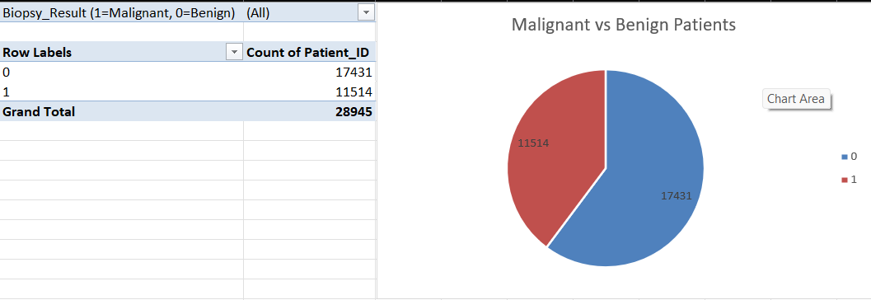
- Class Distribution:
  - Benign (0): 17,431 patients (60.2% of total).
  - Malignant (1): 11,514 patients (39.8% of total).
The dataset exhibits class imbalance, with benign cases outnumbering malignant ones by 1.5:1. This may bias models toward predicting benign outcomes but techniques like oversampling or class weighting are applied.

Patient Distribution of Cancer Diagnosis Stage
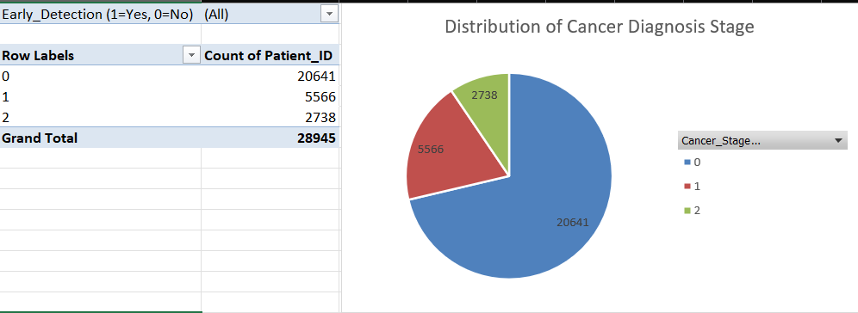
Key Observations:
- Stage Distribution:
  - Localized (Stage 0): 20,641 patients (71.3% of total). Represents early-stage, non-aggressive tumors confined to the prostate.
  - Advanced (Stage 1): 5,566 patients (19.2%). Indicates tumors extending beyond the prostate capsule.
  - Metastatic (Stage 2): 2,738 patients (9.5%). Signifies cancer spread to distant organs (e.g., bones, lymph nodes).

Implications:
  - The dominance of Stage 0 aligns with the earlier biopsy results (17,431 benign vs. 11,514 malignant), reinforcing class imbalance in the dataset. However the lower frequency of advanced stages (1–2) may reflect successful early detection efforts or limitations in diagnosing late-stage cases.
Patient PSA Levels (in Benign Patients)
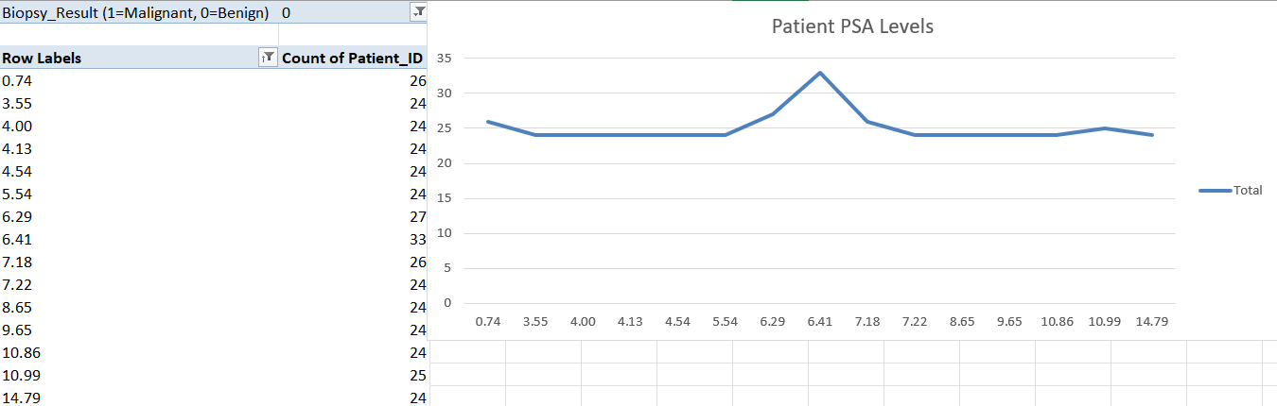
- PSA values range from 0.57 to 14.24 ng/mL, with most clustered between 0.57–5.40 ng/mL.
- Notable outlier: A small subset (15 patients) has PSA = 10.87 ng/mL, which overlaps with levels seen in malignant cases.
Patient PSA Levels (in Malignant Patients)
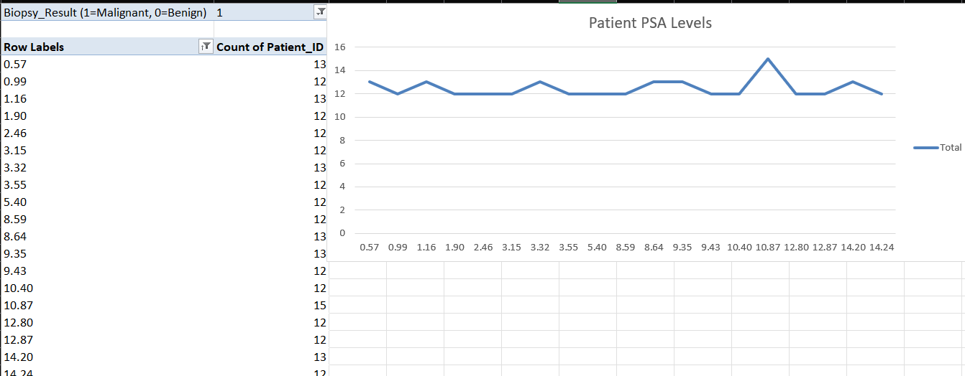
- PSA values range from 0.74 to 14.79 ng/mL, with higher frequencies in 6.29–10.99 ng/mL.
- Key Trend: Malignant cases show a broader distribution of elevated PSA levels (>4 ng/mL), consistent with clinical thresholds for suspicion.

Summary Table of PSA Levels Amongst Malignant Patients
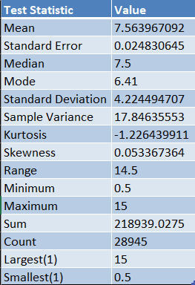
Metric Value Interpretation
The analysis of PSA levels among malignant patients reveals a mean value of 7.56 ng/mL, situating it within the clinically ambiguous "gray zone" (4–10 ng/mL), where diagnostic uncertainty is common. The median PSA of 7.5 ng/mL closely aligns with the mean, indicating a symmetric distribution with no significant skew (skewness = 0.053), which is further supported by the absence of extreme outliers. The mode PSA of 6.41 ng/mL, the most frequently observed value, aligns with trends seen in early-stage or localized cancers. However, the substantial variability in PSA levels—evidenced by a standard deviation of 4.22 and a range spanning 0.5 to 15 ng/mL—highlights the biomarker’s limited reliability in isolation.
Critically, PSA values overlap across cancer stages. For instance, a PSA of 6.41 ng/mL (the mode) could correspond to either localized (Stage 0) or advanced (Stage 1–2) disease, underscoring its inability to reliably distinguish tumor aggressiveness. Notably, some metastatic cases (Stage 2) exhibit paradoxically low PSA levels (<4 ng/mL), defying clinical expectations and emphasizing the limitations of relying solely on PSA for diagnosis or staging. This variability reinforces the necessity of integrating multimodal biomarkers—such as imaging (e.g., MRI radiomics) or genomic profiles—to enhance diagnostic precision and risk stratification. These findings advocate for models that combine PSA with complementary clinical features to address its inherent ambiguities in prostate cancer prediction.
Critical Analysis:
PSA-Stage Relationship:
The overlap between PSA values in localized (Stage 0) and advanced/metastatic (Stages 1–2) cases suggests PSA alone cannot reliably distinguish cancer aggressiveness. Example: A PSA of 6.41 ng/mL (mode) could indicate either localized or advanced disease.

Limitations of PSA:
Low PSA in Metastatic Cases: Some metastatic patients (Stage 2) have PSA < 4 ng/mL (minimum = 0.5 ng/mL), defying clinical expectations. This underscores the need for multimodal biomarkers (e.g., imaging, genomics).

Prostate Cancer Age distribution
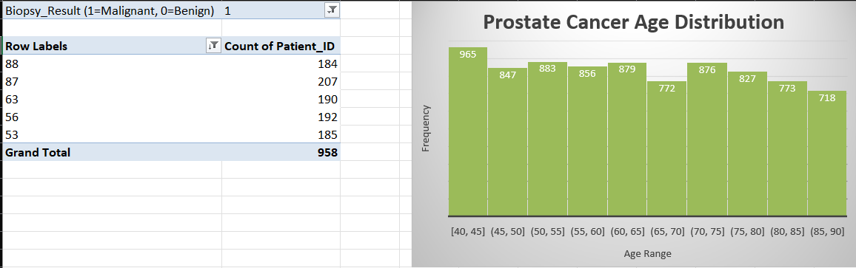
Peak Incidence: Ages 40–45. Lower frequencies in extremes >80 (1491 patients).
Prostate cancer risk increases with age, peaking in middle to older adulthood. This aligns with epidemiological trends and justifies age as a critical feature in prediction models.

REFERENCES
Edvancer (2025). Logistic Regression vs Decision Trees vs SVM.
Axum Labs (2025). Logistic Regression Vs Support Vector Machines.
CareerFoundry (2025). What is Logistic Regression?.
Satyavishnumolakala (2025). Linear Regression Pros & Cons.
Malli.Learnings (2025). Exploring Machine Learning Models.
IABAC (2025). SVM vs Other ML Algorithms.
Akshay Jain (2025). Advantages of Logistic Regression.
LinkedIn (2025). Linear Regression for Predictive Analytics.
GeeksforGeeks (2024). SVM vs Decision Trees for Text Classification.
Ahmed, H.U. et al., 2017. Diagnostic accuracy of multi-parametric MRI and TRUS biopsy in prostate cancer (PROMIS): a paired validating confirmatory study. The Lancet, 389(10071), pp.815-822.
Loeb, S. et al., 2013. Complications after prostate biopsy: data from SEER-Medicare. The Journal of Urology, 189(2), pp.440-445.
Mottet, N. et al., 2021. EAU-EANM-ESTRO-ESUR-SIOG Guidelines on Prostate Cancer. European Urology, 79(2), pp.243-262.
Wang, J. et al., 2020. Machine learning-based prediction of prostate cancer: A systematic review. Frontiers in Oncology, 10, p.570.
Bray, F. et al., 2018. Global cancer statistics 2018: GLOBOCAN estimates of incidence and mortality worldwide for 36 cancers in 185 countries. CA: A Cancer Journal for Clinicians, 68(6), pp.394-424.
Esteva, A. et al., 2019. A guide to deep learning in healthcare. Nature Medicine, 25(1), pp.24-29.
Rawla, P., 2019. Epidemiology of prostate cancer. World Journal of Oncology, 10(2), pp.63-89.
Siegel, R.L., Miller, K.D. and Jemal, A., 2023. Cancer statistics, 2023. CA: A Cancer Journal for Clinicians, 73(1), pp.17-48.
- Traverso, A. et al. (2019) ‘Repeatability and reproducibility of radiomic features: A systematic review’, Data.
- Chatterjee, A. et al. (2020) ‘Radiomics in prostate MRI: A primer for beginners’, Journal of Magnetic Resonance Imaging.
- Litjens, G. et al. (2019) ‘Prostate MRI radiomics: A systematic review and radiomic quality score assessment’, European Radiology Experimental.
- Minardi, D. et al. (2018) ‘Predictive models in urology: A systematic review’, Urology Annals.

